**21110324 - Lương Đăng Khôi**

**Yêu cầu 1**:

Kết quả:

Yêu cầu 2:

Kết quả:

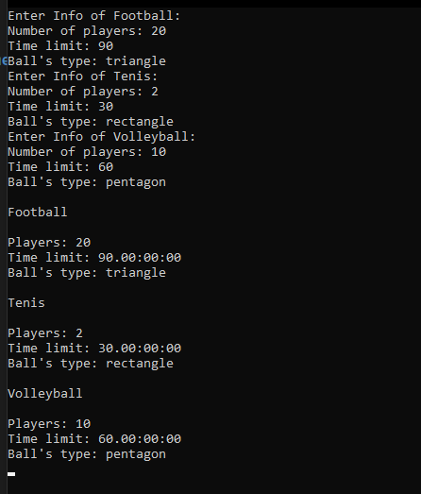

**Mã nguồn Yêu cầu 1:**

using System;

namespace AnimalListManagement

{

using MainData;

class Program

{

static void Main(string[] args)

{

Console.Write("Enter the number of dogs: ");

int dogCount = int.Parse(Console.ReadLine());

Dog[] dogs = new Dog[dogCount];

for (int i = 0; i < dogCount; i++)

{

dogs[i] = new Dog();

Console.WriteLine($"Entering information for Dog {i + 1}:");

dogs[i].InputInfo();

}

Console.Write("Enter the number of cats: ");

int catCount = int.Parse(Console.ReadLine());

Cat[] cats = new Cat[catCount];

for (int i = 0; i < catCount; i++)

{

cats[i] = new Cat();

Console.WriteLine($"Entering information for Cat {i + 1}:");

cats[i].InputInfo();

}

Console.WriteLine("\nDisplaying information of all dogs:");

foreach (var dog in dogs)

{

dog.DisplayInfo();

}

Console.WriteLine("\nDisplaying information of all cats:");

foreach (var cat in cats)

{

cat.DisplayInfo();

}

Console.ReadLine();

}

}

}

namespace MainData

{

public class Animal

{

public string Name { get; set; } = "";

public int Age { get; set; } = 0;

public float Height { get; set; } = 0;

public float Weight { get; set; } = 0;

public void InputAge()

{

bool isComplete = false;

Console.Write($"Enter the age of the {this.GetType().Name}: ");

try

{

Age = int.Parse(Console.ReadLine());

if (Age < 0 || Age > 20)

throw new NegativeNumException();

isComplete = true;

}

catch (FormatException)

{

Console.Write("Somethings went wrong! Please enter again: ");

}

catch (NegativeNumException)

{

Console.Write("Invalid number! Please enter again: ");

}

finally

{

if (!isComplete)

InputAge();

}

}

public enum InputType

{

Height,

Weight

}

public void InputNum(InputType inputType)

{

bool isComplete = false;

string prompt = inputType == InputType.Height ? "height" : "weight";

Console.Write($"Enter the {prompt} of the {this.GetType().Name}: ");

while (!isComplete)

{

try

{

if (inputType == InputType.Height)

Height = float.Parse(Console.ReadLine());

else if (inputType == InputType.Weight)

Weight = float.Parse(Console.ReadLine());

isComplete = true;

}

catch (FormatException)

{

Console.Write("Something went wrong! Please enter again: ");

}

//catch (NegativeNumException)

//{

// Console.Write("Invalid number! Please enter again: ");

//}

}

}

public virtual void InputInfo()

{

Console.Write($"Enter the name of the {this.GetType().Name}: ");

Name = Console.ReadLine();

InputAge();

InputNum(InputType.Height);

InputNum(InputType.Weight);

}

public virtual void DisplayInfo()

{

Console.WriteLine($"Type: {this.GetType().Name}, Name: {Name}, Age: {Age}, Height: {Height}, Weight: {Weight}");

}

public override string ToString()

{

return $"Name: {Name}, Age: {Age}, Height: {Height}, Weight: {Weight}";

}

}

public class NegativeNumException : Exception

{

public NegativeNumException() { }

public NegativeNumException(string message): base(message) { }

}

public class Dog : Animal

{

}

public class Cat : Animal

{

}

}

**Mã nguồn Yêu cầu 2:**

using System;

namespace SportsManagement

{

using MainData;

class Program

{

static void Main(string[] args)

{

Football f = new Football();

Tenis t = new Tenis();

Volleyball v = new Volleyball();

f.InputInfo(); t.InputInfo(); v.InputInfo();

f.DisplayInfo(); t.DisplayInfo(); v.DisplayInfo();

Console.ReadLine();

}

}

}

namespace MainData

{

public class Sport

{

public int Num { get; set; }

public TimeSpan Time { get; set; }

public string Ball { get; set; }

public virtual void InputInfo()

{

Console.WriteLine($"Enter Info of {this.GetType().Name}:");

Console.Write("Number of players: "); Num = int.Parse(Console.ReadLine());

Console.Write("Time limit: "); Time = TimeSpan.Parse(Console.ReadLine());

Console.Write("Ball's type: "); Ball = Console.ReadLine();

}

public void DisplayInfo()

{

Console.WriteLine($"\n{this.GetType().Name}\n");

Console.WriteLine($"Players: {Num}");

Console.WriteLine($"Time limit: {Time}");

Console.WriteLine($"Ball's type: {Ball}");

}

}

public class Football : Sport { }

public class Tenis : Sport { }

public class Volleyball : Sport { }

}